A Scotland That Cares


Information



Easy Read



Copyright images © Photosymbols. Prepared by Disability Equality Scotland 

What is ‘A Scotland That Cares’?
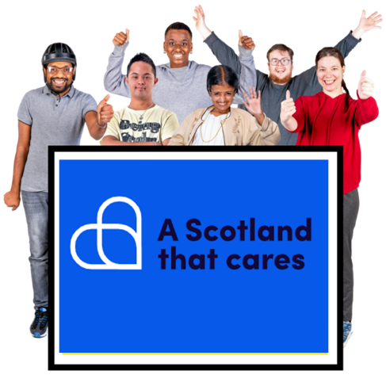 | ‘A Scotland That Cares’ is a new campaign.
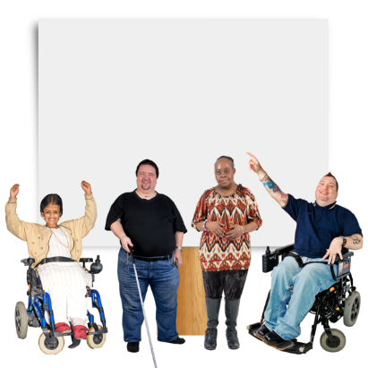 | A campaign is where people join together to send a clear message about something that they want to change.
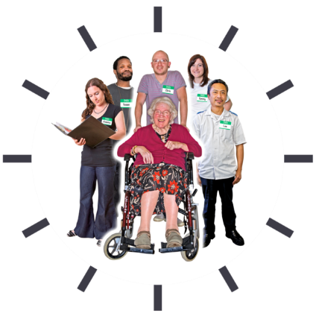 | The campaign wants the Scottish Government to:  - value everyone who works in care  - value everyone who gets care
 | Value means to know and say that someone is very important.
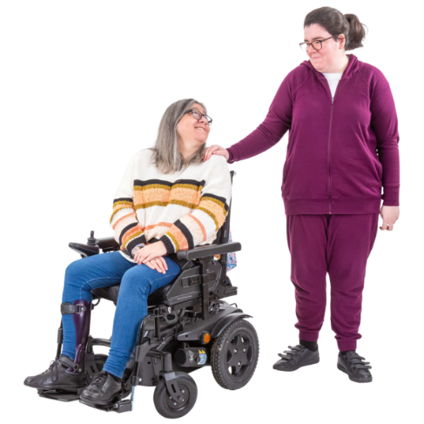 | People who are:  - paid care workers  - unpaid carers  - parents of people needing care  have not been valued enough.
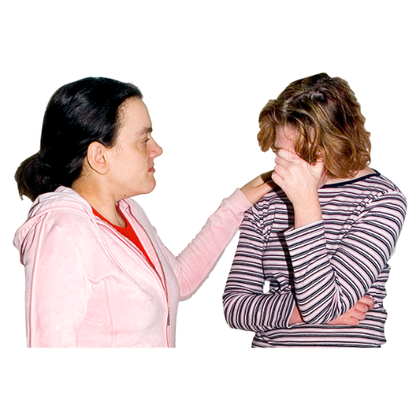 | Lots of these people are struggling with things like paying bills and their own mental health.
 | This was a problem long before COVID-19 happened.  But it became even clearer in the COVID-19 pandemic.
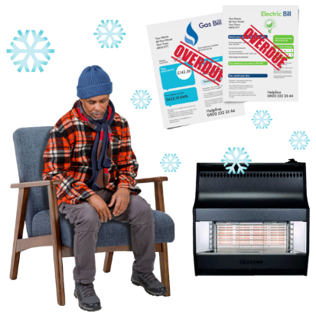 | As well as this problem, these people are now having to pay bigger:  - energy bills  - food bills  - fuel bills
 | This is making more problems for:  - carers  - care workers  - social care services

About the campaign

 | The campaign ‘A Scotland That Cares’ tells the Scottish Government that it needs to value these people with a special promise called a National Outcome.
 | The Scottish Government already has 11 National Outcomes.  It is looking at how well these are going.
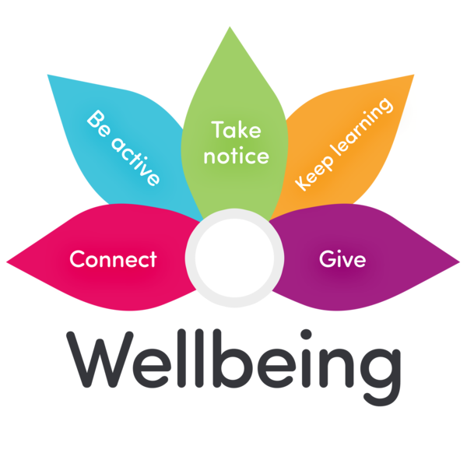 | These 11 National Outcomes are aiming to help everyone feel happier.
 | But none of the National Outcomes is about carers.  We must not leave out carers.
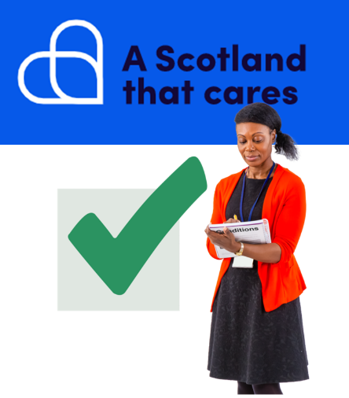 | The campaign wants to make sure that care gets its own new National Outcome.

Who is joining in?

 | More than 50 organisations in Scotland have joined together to make ‘A Scotland That Cares’ happen.  Everyone can join in to support it too.
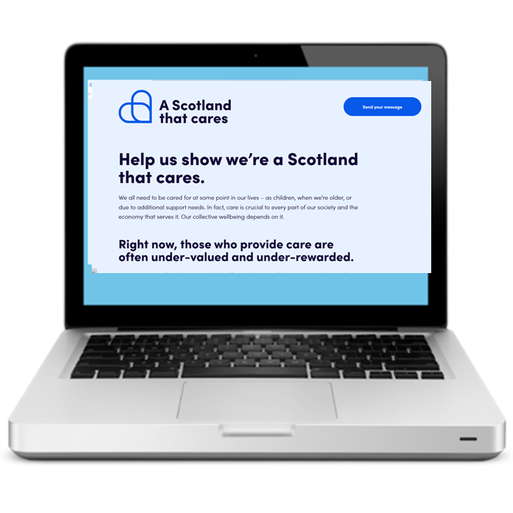 | If you want to support the ‘A Scotland That Cares’, you can click on www.ascotlandthatcares.org.
 | Click the blue button that says ‘Send your message’.
 | Then click the big button that says ‘Let’s Go’.
 | Fill in your name and add a message if you want to.
 | Your message will be sent to the Scottish Parliament.
 | Together we can show that Scotland cares about care.

